**Lesson 2**

Bootstrap

file:///C:/Ema_NW_Source/Bootstrap-Portfolio-master/Bootstrap-Portfolio-master/index.html

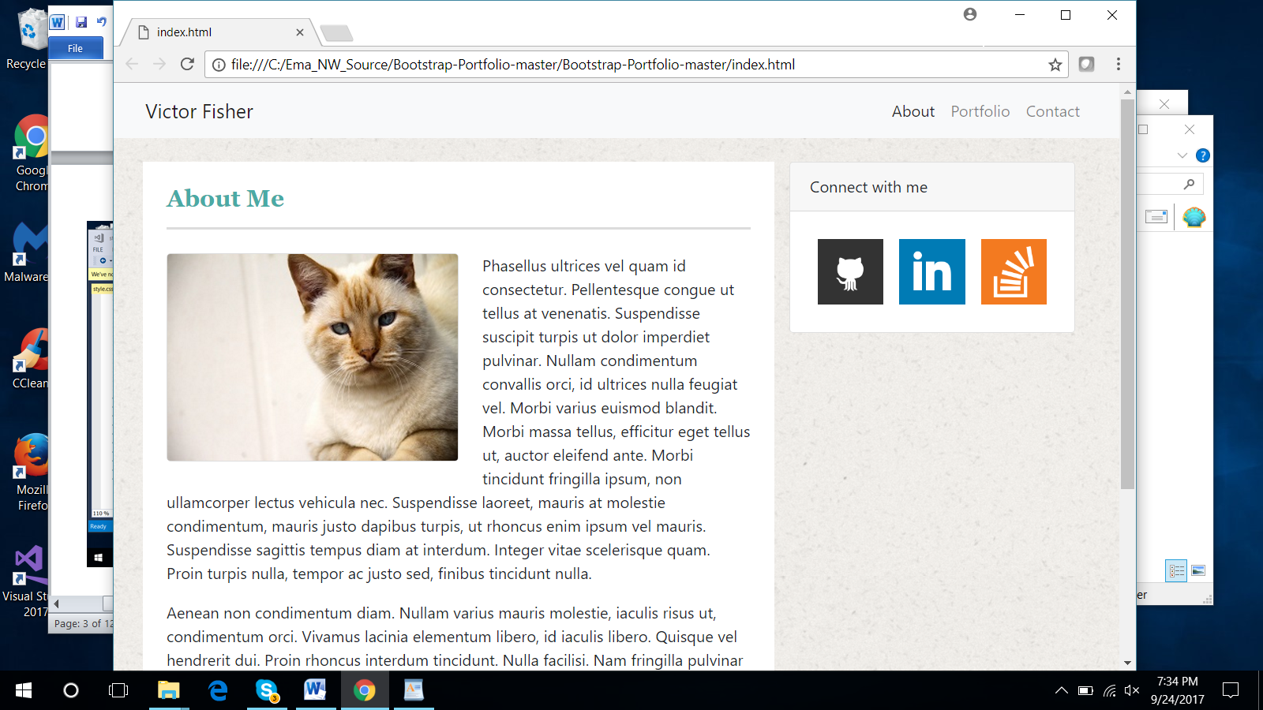

<file:///C:/Ema_NW_Source/Bootstrap-Portfolio-master/Bootstrap-Portfolio-master/portfolio.html>

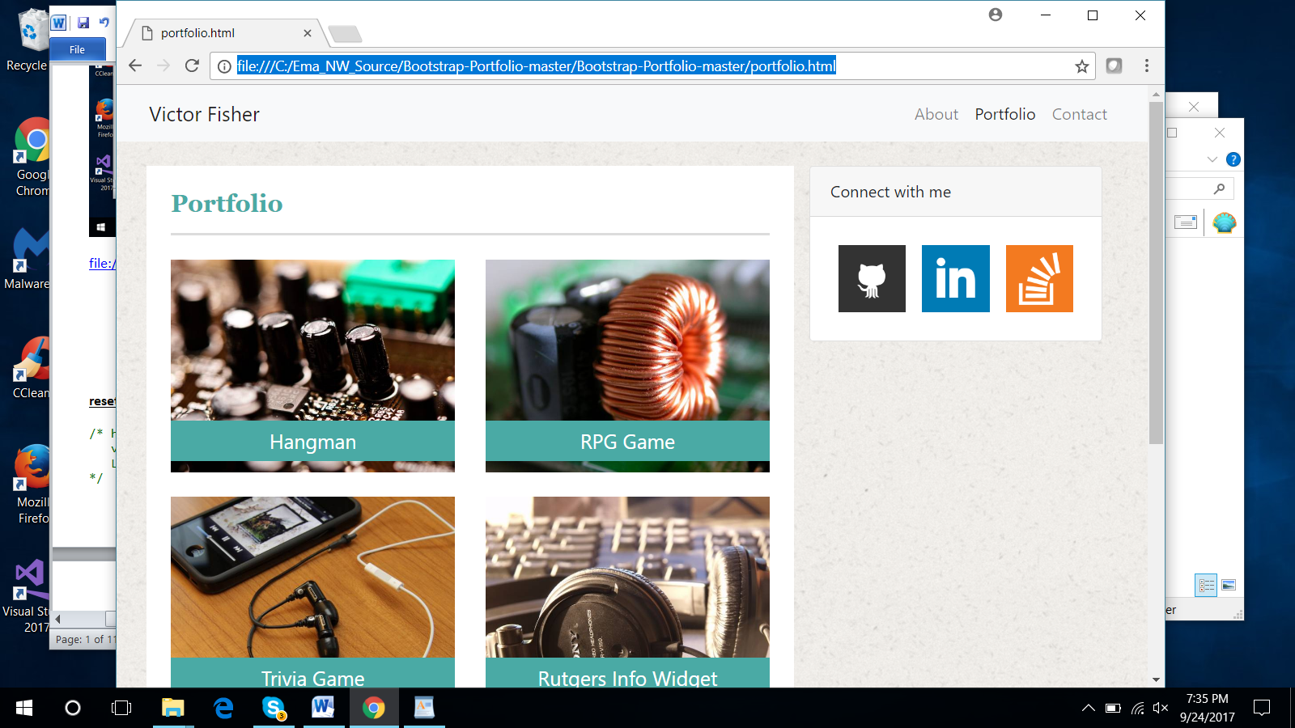

<file:///C:/Ema_NW_Source/Bootstrap-Portfolio-master/Bootstrap-Portfolio-master/contact.html>

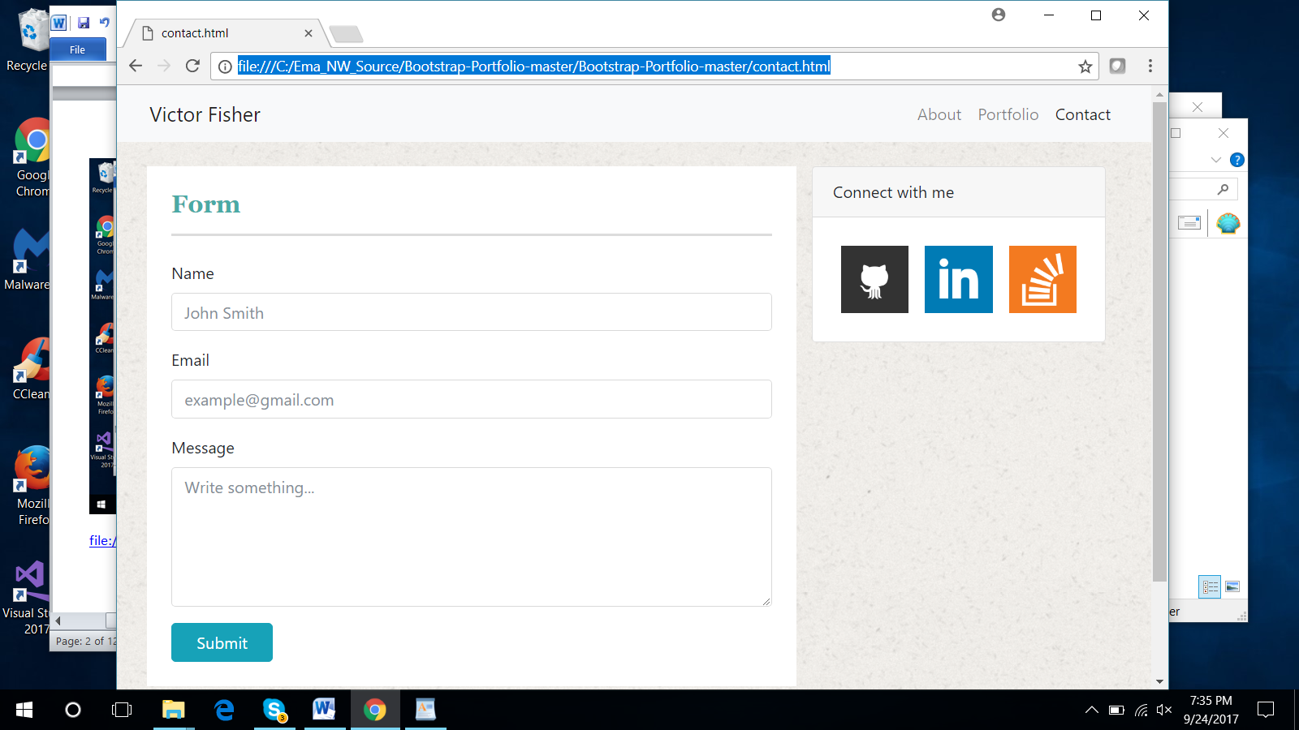

**reset.css**

/* http://meyerweb.com/eric/tools/css/reset/

v2.0 | 20110126

License: none (public domain)

*/

html, body, div, span, applet, object, iframe,

h1, h2, h3, h4, h5, h6, p, blockquote, pre,

a, abbr, acronym, address, big, cite, code,

del, dfn, em, img, ins, kbd, q, s, samp,

small, strike, strong, sub, sup, tt, var,

b, u, i, center,

dl, dt, dd, ol, ul, li,

fieldset, form, label, legend,

table, caption, tbody, tfoot, thead, tr, th, td,

article, aside, canvas, details, embed,

figure, figcaption, footer, header, hgroup,

menu, nav, output, ruby, section, summary,

time, mark, audio, video {

margin: 0;

padding: 0;

border: 0;

font-size: 100%;

font: inherit;

vertical-align: baseline;

}

/* HTML5 display-role reset for older browsers */

article, aside, details, figcaption, figure,

footer, header, hgroup, menu, nav, section {

display: block;

}

body {

line-height: 1;

}

ol, ul {

list-style: none;

}

blockquote, q {

quotes: none;

}

blockquote:before, blockquote:after,

q:before, q:after {

content: '';

content: none;

}

table {

border-collapse: collapse;

border-spacing: 0;

}

**style.css**

.card img:hover {

opacity: 0.75;

}

body {

background-image: url("../images/ricepaper.png");

}

h1 {

font-family: 'Georgia', Times, Times New Roman, serif;

color: #4aaaa5;

font-size: 24px;

font-weight: bold;

}

.hr-thick {

border: none;

height: 2px;

color: gainsboro;

background-color: gainsboro;

}

.navbar:hover .navbar-brand:hover {

color: lightgrey;

}

.navbar:hover .nav-link:hover {

color: lightgrey;

}

#gallery .thumbnail:hover {

opacity: .75;

}

.gallery-unit {

position: relative;

}

.gallery-label {

position: absolute;

bottom: 0;

bottom: 35px;

width: 100%;

color: #ffffff;

font-size: 20px;

background-color: #4aaaa5;

padding-bottom: 5px;

padding-top: 5px;

}

**Index.html**

<!DOCTYPE html>

<html lang="en">

<head>

<!-- Required meta tags -->

<meta charset="utf-8">

<meta name="viewport" content="width=device-width, initial-scale=1, shrink-to-fit=no">

<!-- Reset CSS -->

<link rel="stylesheet" type="text/css" href="assets/reset.css">

<!-- Bootstrap CSS -->

<link href="https://getbootstrap.com/docs/4.0/examples/sticky-footer/sticky-footer.css" rel="stylesheet">

<link rel="stylesheet" href="https://maxcdn.bootstrapcdn.com/bootstrap/4.0.0-beta/css/bootstrap.min.css" integrity="sha384-

/Y6pD6FV/Vv2HJnA6t+vslU6fwYXjCFtcEpHbNJ0lyAFsXTsjBbfaDjzALeQsN6M" crossorigin="anonymous">

<!-- Victor CSS -->

<link rel="stylesheet" type="text/css" href="assets/style.css">

</head>

<body>

<nav class="navbar navbar-expand-lg navbar-light bg-light text-right">

<a class="navbar-brand ml-3" href="#">Victor Fisher</a>

<button class="mr-3 navbar-toggler" type="button" data-toggle="collapse" data-target="#navbarNavAltMarkup" aria-

controls="navbarNavAltMarkup" aria-expanded="false" aria-label="Toggle navigation">

<span class="navbar-toggler-icon"></span>

</button>

<div class="collapse navbar-collapse mr-3" id="navbarNavAltMarkup">

<div class="navbar-nav ml-auto">

<a class="nav-item nav-link active" href="#">About<span class="sr-only">(current)</span></a>

<a class="nav-item nav-link" href="portfolio.html">Portfolio</a>

<a class="nav-item nav-link" href="contact.html">Contact</a>

</div>

</div>

</nav>

<br>

<div class="container">

<div class="row">

<div class="col-md-8 col-sm-12 col-xs-12 bg-white mb-4 pr-4 pl-4">

<h1 class="pt-4">About Me</h1>

<hr class="mb-4 hr-thick">

<img src="images/cat.jpg" alt="cat" id="cat" class="img-thumbnail float-left mr-4 mb-3 col-md-

7 col-lg-6 col-sm-12 col-xs-12 p-0">

<p>Phasellus ultrices vel quam id consectetur. Pellentesque congue ut tellus at venenatis. Suspendisse suscipit turpis ut dolor imperdiet pulvinar. Nullam condimentum convallis orci, id ultrices nulla feugiat vel. Morbi varius euismod blandit. Morbi massa tellus, efficitur eget tellus ut, auctor eleifend ante. Morbi tincidunt fringilla ipsum, non ullamcorper lectus vehicula nec. Suspendisse laoreet, mauris at molestie condimentum, mauris justo dapibus turpis, ut rhoncus enim ipsum vel mauris. Suspendisse sagittis tempus diam at interdum. Integer vitae scelerisque quam. Proin turpis nulla, tempor ac justo sed, finibus tincidunt nulla.</p>

<p>Aenean non condimentum diam. Nullam varius mauris molestie, iaculis risus ut, condimentum orci. Vivamus lacinia elementum libero, id iaculis libero. Quisque vel hendrerit dui. Proin rhoncus interdum tincidunt. Nulla facilisi. Nam fringilla pulvinar vestibulum. Nulla quis auctor mi. Donec quis ultricies mi. Curabitur varius felis purus. Nunc magna massa, porttitor eu maximus a, sollicitudin sit amet elit. Sed consectetur erat lectus, sit amet gravida nulla aliquam nec. In viverra eros ut aliquet ornare. Proin justo arcu, sagittis quis purus in, ullamcorper lacinia sapien. Sed et felis nisl.</p>

</div>

<div class="col-md-4 col-sm-12 col-xs-12">

<div class="card">

<div class="card-header">

Connect with me

</div>

<div class="card-body d-flex flex-row">

<a class="p-2" href="https://www.github.com/deep-research" target="_blank"><img

src="images/github.png" alt="GitHub" class="img-fluid"></a>

<a class="p-2" href="https://www.linkedin.com/in/victor-fisher-3220a4143/"

target="_blank"><img src="images/linkedin.png" alt="LinkedIn"

class="img-fluid"></a>

<a class="p-2" href="https://stackoverflow.com/users/8310067/deep-research"

target="_blank"><img src="images/stack-overflow.png" alt="Stack Overflow"

class="img-fluid"></a>

</div>

</div>

</div>

</div>

</div>

<br><br><br><br>

<footer class="footer">

<div class="container text-center">

<span class="text-muted col-xs-12 text-nowrap">© Copywrite 2017 Victor Fisher</span>

</div>

</footer>

<!-- Optional JavaScript -->

<!-- jQuery first, then Popper.js, then Bootstrap JS -->

<script src="https://code.jquery.com/jquery-3.2.1.slim.min.js" integrity="sha384-

KJ3o2DKtIkvYIK3UENzmM7KCkRr/rE9/Qpg6aAZGJwFDMVNA/GpGFF93hXpG5KkN" crossorigin="anonymous"></script>

<script src="https://cdnjs.cloudflare.com/ajax/libs/popper.js/1.11.0/umd/popper.min.js" integrity="sha384-

b/U6ypiBEHpOf/4+1nzFpr53nxSS+GLCkfwBdFNTxtclqqenISfwAzpKaMNFNmj4" crossorigin="anonymous"></script>

<script src="https://maxcdn.bootstrapcdn.com/bootstrap/4.0.0-beta/js/bootstrap.min.js" integrity="sha384-

h0AbiXch4ZDo7tp9hKZ4TsHbi047NrKGLO3SEJAg45jXxnGIfYzk4Si90RDIqNm1" crossorigin="anonymous"></script>

</body>

</html>

**portfolio.html**

<!DOCTYPE html>

<html lang="en">

<head>

<!-- Required meta tags -->

<meta charset="utf-8">

<meta name="viewport" content="width=device-width, initial-scale=1, shrink-to-fit=no">

<!-- Reset CSS -->

<link rel="stylesheet" type="text/css" href="assets/reset.css">

<!-- Bootstrap CSS -->

<link href="https://getbootstrap.com/docs/4.0/examples/sticky-footer/sticky-footer.css" rel="stylesheet">

<link rel="stylesheet" href="https://maxcdn.bootstrapcdn.com/bootstrap/4.0.0-beta/css/bootstrap.min.css"

integrity="sha384-

/Y6pD6FV/Vv2HJnA6t+vslU6fwYXjCFtcEpHbNJ0lyAFsXTsjBbfaDjzALeQsN6M" crossorigin="anonymous">

<!-- Victor CSS -->

<link rel="stylesheet" type="text/css" href="assets/style.css">

</head>

<body>

<nav class="navbar navbar-expand-lg navbar-light bg-light text-right">

<a class="navbar-brand ml-3" href="index.html">Victor Fisher</a>

<button class="mr-3 navbar-toggler" type="button" data-toggle="collapse" data-target="#navbarNavAltMarkup"

aria-

controls="navbarNavAltMarkup" aria-expanded="false" aria-label="Toggle navigation">

<span class="navbar-toggler-icon"></span>

</button>

<div class="collapse navbar-collapse mr-3" id="navbarNavAltMarkup">

<div class="navbar-nav ml-auto">

<a class="nav-item nav-link" href="index.html">About<span class="sr-only">(current)</span></a>

<a class="nav-item nav-link active" href="portfolio.html">Portfolio</a>

<a class="nav-item nav-link" href="contact.html">Contact</a>

</div>

</div>

</nav>

<br>

<div class="container">

<div class="row">

<div class="col-md-8 col-sm-12 col-xs-12 bg-white mb-4 pr-4 pl-4" id="gallery">

<h1 class="pt-4">Portfolio</h1>

<hr class="mb-4 hr-thick">

<!-- Image Gallery -->

<div class = "row">

<div class="col-sm-12 col-md-6">

<div class="gallery-unit">

<a href="#" class="thumbnail">

<div class="gallery-label text-center">Hangman</div>

<img class="img-fluid mb-4" src="images/board.jpg" alt="Curcuit Board">

</a>

</div>

</div>

<div class="col-sm-12 col-md-6">

<div class="gallery-unit">

<a href="#" class="thumbnail">

<div class="gallery-label text-center">RPG Game</div>

<img class="img-fluid mb-4" src="images/coil.jpg" alt="Copper Wire

Coil">

</a>

</div>

</div>

</div>

<div class="row">

<div class= "col-sm-12 col-md-6">

<div class="gallery-unit">

<a href="#" class="thumbnail">

<div class="gallery-label text-center">Trivia Game</div>

<img class="img-fluid mb-4" src="images/ipod.jpg" alt="Apple iPod">

</a>

</div>

</div>

<div class="col-sm-12 col-md-6">

<div class="gallery-unit">

<a href="#" class="thumbnail">

<div class="gallery-label text-center">Rutgers Info Widget</div>

<img class="img-fluid mb-4" src="images/studio.jpg" alt="Recording

Studio">

</a>

</div>

</div>

</div>

<div class="row">

<div class="col-sm-12 col-md-6">

<div class="gallery-unit">

<a href="#" class="thumbnail">

<div class="gallery-label text-center">Rock Paper Scissors</div>

<img class="img-fluid mb-4" src="images/turntable.jpg" alt="DJ

Turntable">

</a>

</div>

</div>

</div>

</div>

<div class="col-md-4 col-sm-12 col-xs-12">

<div class="card">

<div class="card-header">

Connect with me

</div>

<div class="card-body d-flex flex-row">

<a class="p-2" href="https://www.github.com/deep-research"

target="_blank"><img src="images/github.png" alt="GitHub" class="img-

fluid"></a>

<a class="p-2" href="https://www.linkedin.com/in/victor-fisher-3220a4143/"

target="_blank"><img src="images/linkedin.png" alt="LinkedIn" class="img-

fluid"></a>

<a class="p-2" href="https://stackoverflow.com/users/8310067/deep-research"

target="_blank"><img src="images/stack-overflow.png" alt="Stack Overflow"

class="img-fluid"></a>

</div>

</div>

</div>

</div>

</div>

<br><br><br><br>

<footer class="footer">

<div class="container text-center">

<span class="text-muted col-xs-12 text-nowrap">© Copywrite 2017 Victor Fisher</span>

</div>

</footer>

<!-- Optional JavaScript -->

<!-- jQuery first, then Popper.js, then Bootstrap JS -->

<script src="https://code.jquery.com/jquery-3.2.1.slim.min.js" integrity="sha384-

KJ3o2DKtIkvYIK3UENzmM7KCkRr/rE9/Qpg6aAZGJwFDMVNA/GpGFF93hXpG5KkN" crossorigin="anonymous"></script>

<script src="https://cdnjs.cloudflare.com/ajax/libs/popper.js/1.11.0/umd/popper.min.js" integrity="sha384-

b/U6ypiBEHpOf/4+1nzFpr53nxSS+GLCkfwBdFNTxtclqqenISfwAzpKaMNFNmj4"

crossorigin="anonymous"></script>

<script src="https://maxcdn.bootstrapcdn.com/bootstrap/4.0.0-beta/js/bootstrap.min.js" integrity="sha384-

h0AbiXch4ZDo7tp9hKZ4TsHbi047NrKGLO3SEJAg45jXxnGIfYzk4Si90RDIqNm1"

crossorigin="anonymous"></script>

</body>

</html>

**contact.html**

<!DOCTYPE html>

<html lang="en">

<head>

<!-- Required meta tags -->

<meta charset="utf-8">

<meta name="viewport" content="width=device-width, initial-scale=1, shrink-to-fit=no">

<!-- Reset CSS -->

<link rel="stylesheet" type="text/css" href="assets/reset.css">

<!-- Bootstrap CSS -->

<link href="https://getbootstrap.com/docs/4.0/examples/sticky-footer/sticky-footer.css" rel="stylesheet">

<link rel="stylesheet" href="https://maxcdn.bootstrapcdn.com/bootstrap/4.0.0-beta/css/bootstrap.min.css"

integrity="sha384-

/Y6pD6FV/Vv2HJnA6t+vslU6fwYXjCFtcEpHbNJ0lyAFsXTsjBbfaDjzALeQsN6M" crossorigin="anonymous">

<!-- Victor CSS -->

<link rel="stylesheet" type="text/css" href="assets/style.css">

</head>

<body>

<nav class="navbar navbar-expand-lg navbar-light bg-light text-right">

<a class="navbar-brand ml-3" href="index.html">Victor Fisher</a>

<button class="mr-3 navbar-toggler" type="button" data-toggle="collapse"

data-target="#navbarNavAltMarkup" aria-

controls="navbarNavAltMarkup" aria-expanded="false" aria-label="Toggle navigation">

<span class="navbar-toggler-icon"></span>

</button>

<div class="collapse navbar-collapse mr-3" id="navbarNavAltMarkup">

<div class="navbar-nav ml-auto">

<a class="nav-item nav-link" href="index.html">About<span class="sr-only">(current)</span></a>

<a class="nav-item nav-link" href="portfolio.html">Portfolio</a>

<a class="nav-item nav-link active" href="contact.html">Contact</a>

</div>

</div>

</nav>

<br>

<div class="container">

<div class="row">

<div class="col-md-8 col-sm-12 col-xs-12 bg-white mb-4 pr-4 pl-4">

<h1 class="pt-4">Form</h1>

<hr class="mb-4 hr-thick">

<form>

<div class="form-group">

<label for="exampleFormControlInput1">Name</label>

<input type="text" class="form-control" id="exampleFormControlInput1"

placeholder="John Smith">

</div>

<div class="form-group">

<label for="exampleFormControlInput1">Email</label>

<input type="email" class="form-control" id="exampleFormControlInput1"

placeholder="example@gmail.com">

</div>

<div class="form-group">

<label for="exampleFormControlTextarea1">Message</label>

<textarea class="form-control" placeholder="Write something..."

id="exampleFormControlTextarea1" rows="6"></textarea>

</div>

<button type="button" class="btn btn-info pl-4 pr-4 pb-2 pt-2">Submit</button>

<br><br>

</form>

</div>

<div class="col-md-4 col-sm-12 col-xs-12">

<div class="card">

<div class="card-header">

Connect with me

</div>

<div class="card-body d-flex flex-row">

<a class="p-2" href="https://www.github.com/deep-research"

target="_blank"><img

src="images/github.png" alt="GitHub" class="img-fluid"></a>

<a class="p-2" href="https://www.linkedin.com/in/victor-fisher-3220a4143/"

target="_blank"><img src="images/linkedin.png" alt="LinkedIn"

class="img-fluid"></a>

<a class="p-2" href="https://stackoverflow.com/users/8310067/deep-research"

target="_blank"><img src="images/stack-overflow.png" alt="Stack

Overflow" class="img-fluid"></a>

</div>

</div>

</div>

</div>

</div>

<br><br><br><br>

<footer class="footer">

<div class="container text-center">

<span class="text-muted col-xs-12 text-nowrap">© Copywrite 2017 Victor Fisher</span>

</div>

</footer>

<!-- Optional JavaScript -->

<!-- jQuery first, then Popper.js, then Bootstrap JS -->

<script src="https://code.jquery.com/jquery-3.2.1.slim.min.js" integrity="sha384-

KJ3o2DKtIkvYIK3UENzmM7KCkRr/rE9/Qpg6aAZGJwFDMVNA/GpGFF93hXpG5KkN" crossorigin="anonymous"></script>

<script src="https://cdnjs.cloudflare.com/ajax/libs/popper.js/1.11.0/umd/popper.min.js" integrity="sha384-

b/U6ypiBEHpOf/4+1nzFpr53nxSS+GLCkfwBdFNTxtclqqenISfwAzpKaMNFNmj4"

crossorigin="anonymous"></script>

<script src="https://maxcdn.bootstrapcdn.com/bootstrap/4.0.0-beta/js/bootstrap.min.js" integrity="sha384-

h0AbiXch4ZDo7tp9hKZ4TsHbi047NrKGLO3SEJAg45jXxnGIfYzk4Si90RDIqNm1"

crossorigin="anonymous"></script>

</body>

</html>